Hach IIM WIMS Implementation
Services are provided by the Hach IIM Project Team to ensure a successful implementation. The implementation provides a solid foundation and allows our customers to hit the ground running. A project manager will be assigned who, together with the customer, will complete the implementation. Training is provided where the customer will be taught system basics and how to setup additional forms, reports, parameters, calculations, and graphs. If the customer requires additional services or training they can be purchased at any time.
Typical Project Implementation Plan:
Project kickoff meeting
Web Meeting/Conference Call covering:
- Stakeholders identified
- Mutual understanding of Expectations (who does what and when)
- Installation Consulting
- Project Description and schedule development
- User/Security Planning
- Project Questionnaire/Request for information (i.e. existing reports, Excel Sheets, permits, etc...) will be reviewed and sent to customer.

Scope of Work
A Scope Of Work (SOW) will be created listing the project deliverables (i.e. reports, forms to be created, etc..) and activities required by each party. The customer will be sent the SOW and both the Project Manager and customer will be required to sign before project can continue.
Initial Database Setup
Your Project Manager will create a basic framework of your database based on locations/parameters identified in the Process Questionnaire and RFI.
Database Review Meeting
Web Meeting/Conference Call to review initial database setup. Verify locations and overall processes have been identified. User will identify their Key Performance Indicators for use in Dashboards and reports. See attached Key Performance Indicator Questionnaire.

Database Setup
Based on meetings, RFI, and Process Questionnaire your Project Manager will setup the WIMS variables (parameters), calculations will be identified, basic formulas will be setup, and permit limits entered.

Regulatory Report Setup
The regulatory reports identified in the SOW will be created and configured to your specific system.
Database Review
Web Meeting with client to review database. Edits will be made to the database, reports and notes taken to finish the database.
Final Database Setup
Based on database review with client, final edits to variable list and locations will be completed.
Calculation Setup
Web Meetings will be setup to work with the client to setup/test site specific calculations such as F/M ratio, MCRT, CT, and chemical dosage calculations. Note: basic formulas (loadings, monthly averages, etc…) will be setup by the Project Manager during Database Setup. Users will be trained on how to finish calculation setup (if required) during training.
Basic Form and Report Development
KPI reports and basic Data Entry Form Setup identified in the SOW will be created and configured to your specific system. Deliverables typically include the following:
- 1 Standard format monthly KPI report
- KPI graph set
- 1 Standard format yearly summary KPI report
- Predefined dashboard with user defined KPI's
- 1 Custom data entry benchsheet
- Standard Monthly Data Entry Forms for all parameters
Test Data Entry/Regulatory Report Testing
IIM Project Manager will enter a small subset of data from user's existing data (Excel Sheets, Paper forms, etc…) in order to test data entry forms and reports.
Database Review
Web Meeting with client to review database and verify it is ready for delivery to client. Edits made to database based on review.
Remote Basic Install Assistance
Via Web Meeting – Working with your staff (IT, plant personnel, etc…) we will step you through the install of Hach WIMS on server and 1 client. Instructions on how to install on other clients will be delivered. This step is required for both remote and on-site project delivery and MUST be done prior to on-site startup/training.
Remote Basic Interface Install Assistance
Via Web Meeting – Working with your staff (SCADA expert, LIMS admin, IT, plant personnel, etc…) we will step you through the install of Hach WIMS interfaces.
Training
1 ½ days of training covering:
- Basic User – How to use WIMS focusing on day-to-day operation including entering data, running reports, and graphing data.
- Power User – How to get more out of WIMS including Report and Form Design, Calculation setup, understanding security, etc…
- Admin Training – Covering system architecture, backup, security setup, troubleshooting services and interfaces.
- Training and Admin Guides will be provided: One (1) printed version and electronic copies.
Project Signoff
Upon completion of the project, the Project Manager will review the SOW with the client and get final project approval. Customer will enter into the Hach IIM Support program.

Sample Deliverables

An organized variable/parameter list:
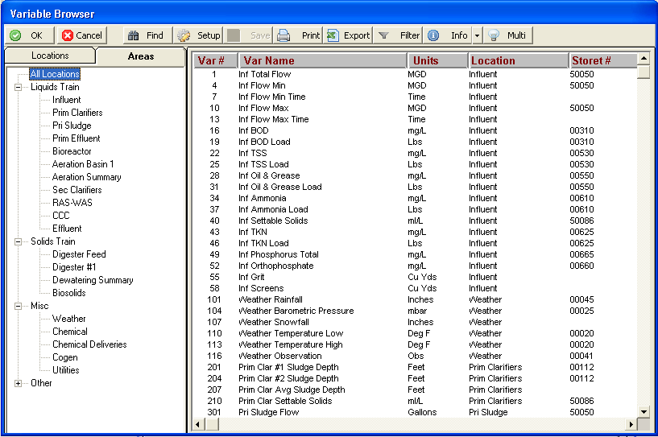

Regulatory reports (or eReports) as specified in the Scope of Work:
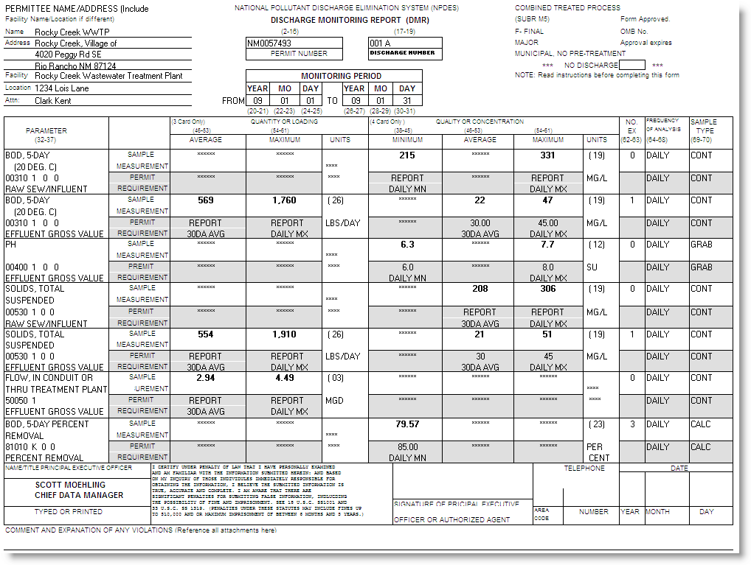
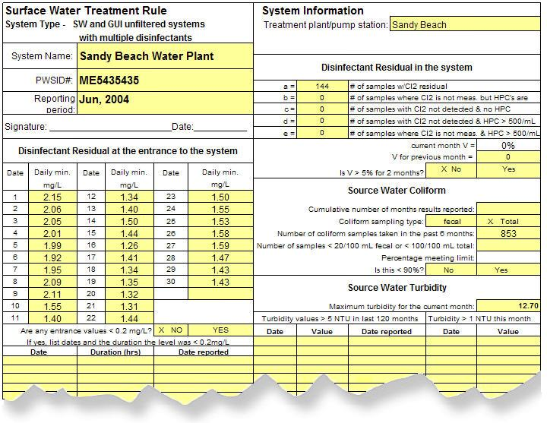

Dashboard with Key Performance Indicator Data and shortcuts to your data entry forms, reports and graphs:

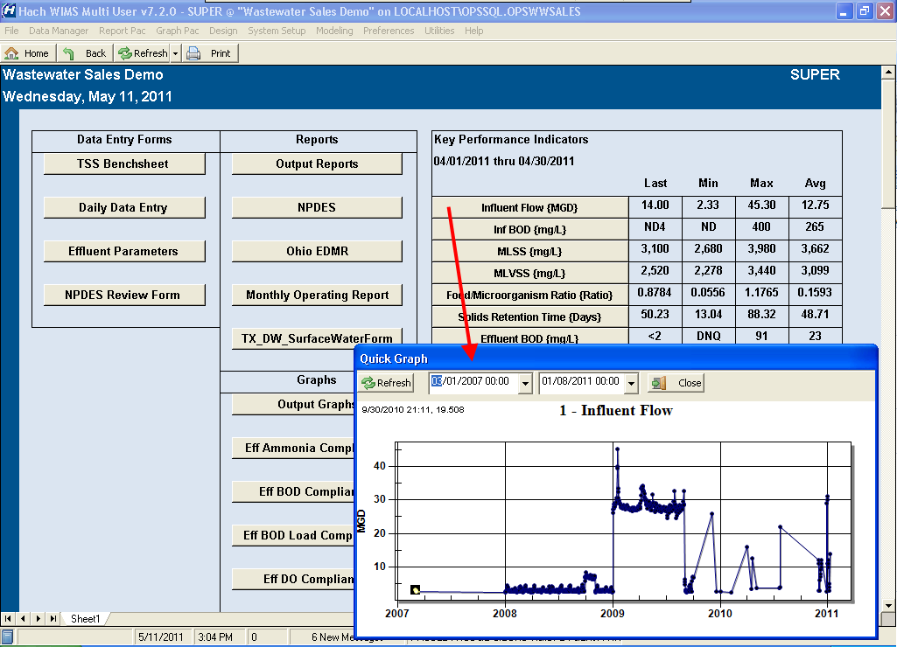

Key Performance Indicator Reports:
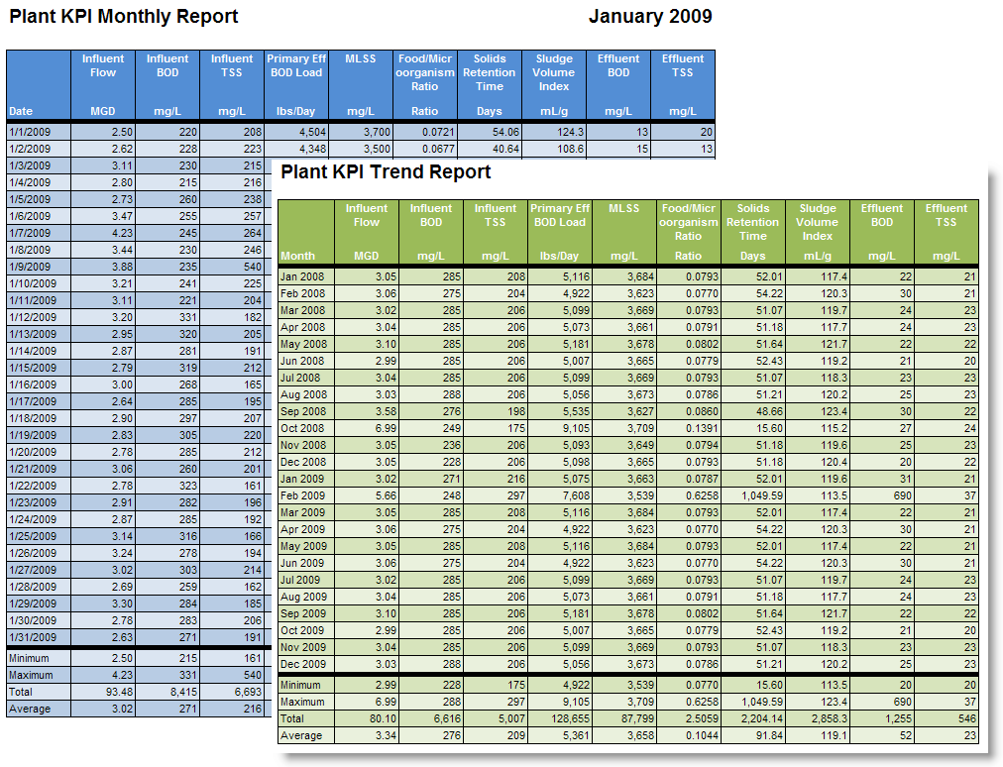

Data Entry Forms to enter/review/approve all your data:
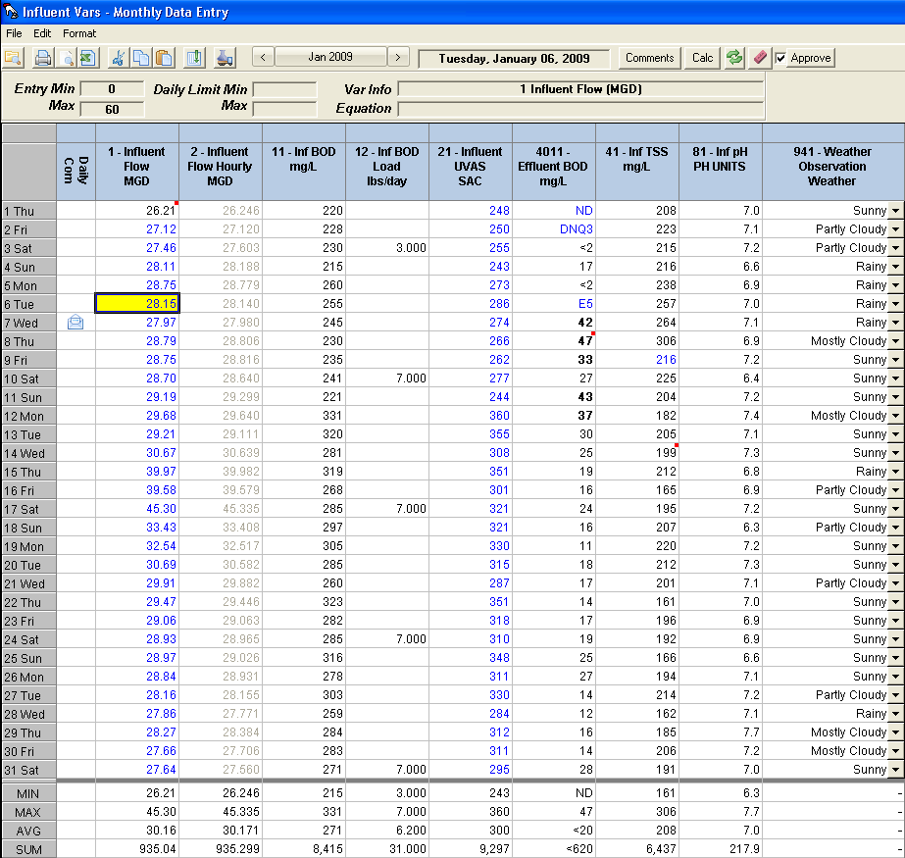

One Custom Data Entry Form/Benchsheet:

